CHARITY FAMILY of VIRGINIA
Scholarship Fund Committee
Faith C. Nelson, Committee Chair
318 Chipper Way, Henrico, VA 23075

Dear Charity Family:

Cousin Bruce Harrell has completed a book of the Charity Name Index for Cousin Edna’s book (AKA “THE BIG GREEN BOOK”).
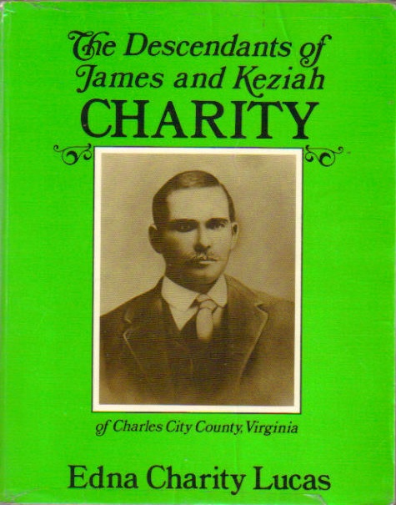“The Descendants of James and Keziah Charity of Charles City County, Virginia” by Edna Charity Lucas, “NAME INDEX,” by Bruce W. Harrell is a great tool for you when looking for a family member’s name. We are happy to say that Bruce has decided to make this a fund raiser for the Charity Family Scholarship Fund. The cost of this book is $20.00 and Bruce will donate $5.00 toward the Charity Family Scholarship Fund for each sale. Below is a form for you to place your orders.
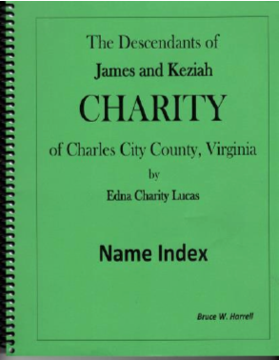

Much Love,

The CF Scholarship Committee, Faith C. Nelson, Chair
Gloria Harver – Treasurer
Linda Washington - Member
Sabrena Brandon – Member
Donald Charity – Member
Dionna Dunbar - Member

.

Original Charity Family Heirloom

CHARITY FAMILY BOOK NAME INDEX ORDER FORM
Please click and type, then print and mail to the address below or pay via PayPal account below.

Name Click here to enter text.

Address Click here to enter text.

City, State and Zip Click here to enter text.

Email address Click here to enter text.

Number of books you are requesting Click here to enter text. X $20.00 each = Click here to enter text.

Make payment via our website: www.charityfamilyreunion.com

Make payment to our PayPal Charity Scholarship Fund Account: cfsfunds10@gmail.com
Make check payable to: Charity Family Scholarship Fund and mail payment to:
Gloria Harver, 7374 Cedar Avenue, Jessup, MD 20794
Thank you!

